Rogue River Watershed
Green Team:
Looking for High School Students for Summer 2020!

The Rogue River is a major tributary of the Grand River and is a high quality coldwater system located in West Michigan. The watershed is 167,625 acres and is an extremely important trout fishery resource in southern Michigan. Based on a 2015 economic study, the Rogue River brings in roughly $7.3 million every summer in recreational activities to the local communities. However, the Rogue River watershed lies in the urban shadow of one of the fastest growing areas in Michigan. Fluctuating water temperature and sedimentation from stormwater runoff are serious issues in the Rogue River and its tributaries.
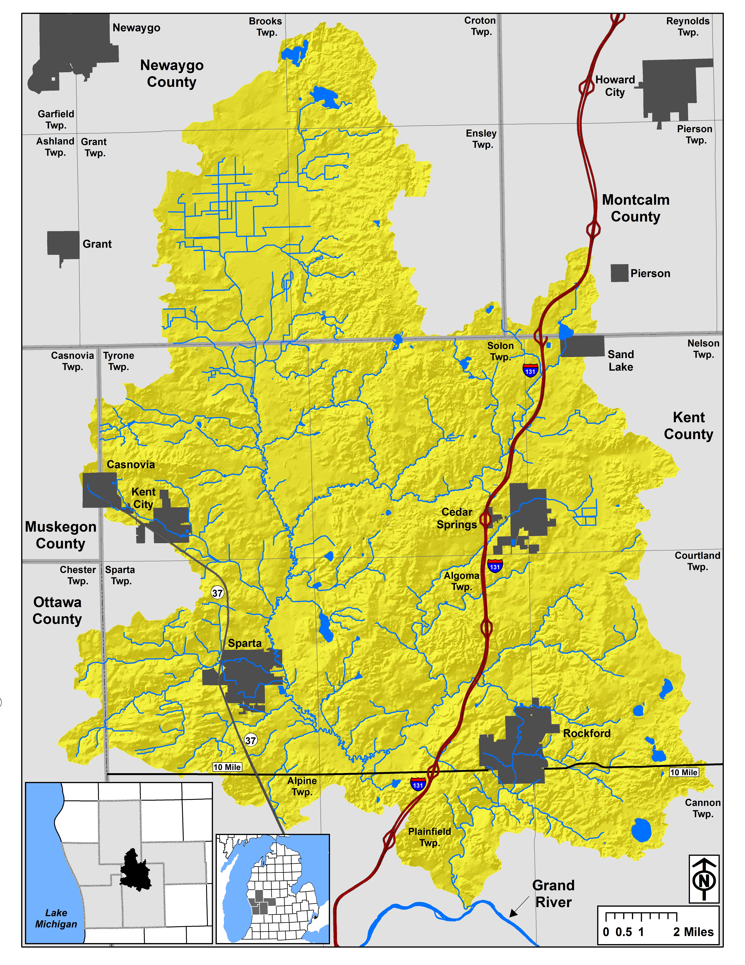
Rogue River Watershed in yellow.

The Rogue River watershed is one of Trout Unlimited’s Home Rivers Initiatives, which are multi-year collaborative integrated watershed restoration projects. Local foundations and other donors have contributed funds towards the Rogue River Home Rivers Initiative project. This project focuses on restoration actions and education to improve existing river conditions, working with local governments to improve municipal planning, and increasing capacity to help ensure advocates for long-term protection of the Rogue.

To help achieve our goals, we will be conducting our Green Team program this summer (June/July 2020). We are looking to hire high school students with roots in the Rogue River watershed (home or school). Our summer Green Team crew will learn about native Michigan habitats and watershed ecology as they work on rain gardens and stream buffers in areas throughout the watershed. Green Team members will learn the ins and outs of propagating native plants, which we use in our restoration projects, and they will gain valuable job and research experience working alongside Trout Unlimited staff.

If you are interested in applying for the 2020 Green Team, please contact Jamie Vaughan at jvaughan@tu.org for an application. Applications will be accepted until April 13, 2020.

