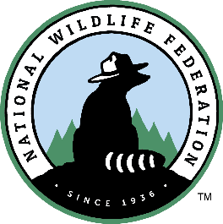
Sacred Grounds Grand Rapids Mini-Grant Application
Deadline: December 20, 2019

Please complete and return this form to Manja Holland via email at hollandm@nwf.org. Questions can be directed to Mai Allyn Del Angel (mai.allyn.pham@gmail.com). We will notify you of your application status by January 14, 2020.

Name of Congregation, Faith Community, or House of Worship:

Congregation Address:

Primary Contact First Name:

Primary Contact Last Name:

Primary Contact Email Address:

Primary Contact Phone Number:

What is the best way to contact you – phone or email?

Secondary Contact Name:

Secondary Contact Email Address:

Secondary Contact Phone Number:

Congregation Leader (Director, Clergy, etc.):

Congregation Phone:

Congregation denomination:

Why do you want to participate in this program? Please described in a few sentences or a short paragraph.

Please list and briefly describe 2-3 current volunteer or community efforts your house of worship has engaged in.

Does your house of worship have a green team or other group of individuals working together on environmental issues? Approximately how many members of your faith community do you anticipate being willing/interested to engage in this project?

